#### Q-15. Write an SQL query to fetch intersecting records of two tables.

(SELECT * FROM Worker) INTERSECT (SELECT * FROM WorkerClone);

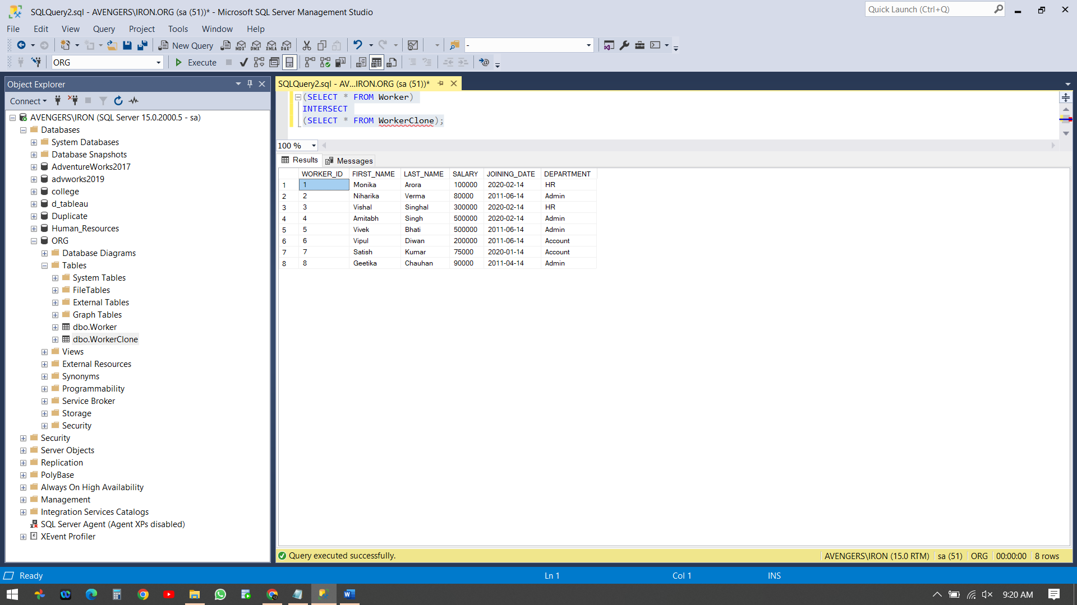

#### Q-16. Write an SQL query to show records from one table that another table does not have.

SELECT * FROM Worker

Select * from WorkerClone

Select * FROM Worker

WHERE WORKER_ID NOT IN

(SELECT WORKER_ID

#### FROM WorkerClone)

#### 